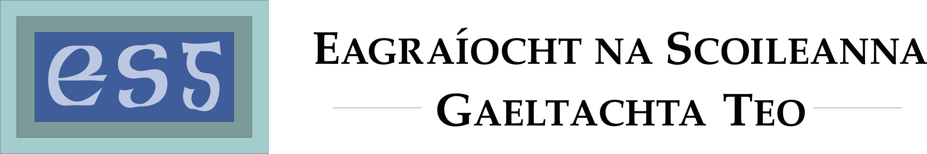

Thursday, 29 November 2012: for immediate publication

Eagraíocht na Scoileanna Gaeltachta Teo. and GAELSCOILEANNA TEO. express disappointment at the reduction in status for An Chomhairle Um Oideachais Gaeltachta agus Gaelscolaíochta.

The steering committees of Eagraíocht na Scoileanna Gaeltachta Teo. and Gaelscoileanna Teo. acknowledge that the two organisations ran an excellent joint conference, themed ‘Féinmheastóireacht, Forbairt, Feabhas– Self-assessment, Development, Excellence’, in the Ardilaun Hotel in Galway last Friday. More than 300 people attended the conference, the most to ever attend an Irish-medium educational conference to date. First class workshops were provided for the participants as well as comprehensive information regarding resources available through Irish from companies that had stands at the conference.

The participants and all the schools were taken aback when the General Secretary of the Department of Education and Skill, Seán Ó Foghlú, announced that An Chomhairle Um Oideachais Gaeltachta agus Gaelscolaíochta (COGG) was to be integrated with the National Council for Curriculum and Assessment (NCCA). The two organisations are highly disappointed that the Department is planning this and are certain that this decision will take from COGG’s ability to function as an independent entity and as an organisation that functions completely through the medium of Irish. Speaking on behalf of Eagraíocht na Scoileanna Gaeltachta Teo. Treasa Ní Mhainín, Chief Executive of the organisation, said, “it is evident that the Department of Education and Skills is not applying the 20 Year Strategy for the Irish Language by implementing this reduction in status. The Strategy mentions that the appropriate staff and resources will be made available to the Comhairle in order to allow it fulfil its duties but it is evident that the Department is not fulfilling its own duties regarding the Strategy in this case.” It is also mentioned in the plan that COGG ‘will play a key role in the implementation of the Strategy in the education sector’. How can COGG have such a key role if the Department of Education is reducing its powers?

It will be a big challenge for the schools not being able to do all their business with COGG through the medium of Irish. This will be impossible when COGG will be merged with the NCCA, where most of the staff that work there don’t speak Irish fluently. This even illustrates that there won’t be any financial saving as COGG will still have to do all its own administration.

“It is the schools that will be negatively impacted when there is a danger that the status of COGG will be further reduced over the following years and, therefore, that the same supply of resources won’t be available to schools that are teaching through the medium of Irish. Even though the amount of resources through Irish for these schools have improved they always need to be added to and as the curriculum changes further resources will be needed”, according to Máirín Ní Chéileachair, President of Gaelscoileanna Teo.

The two organisations will be fighting strongly against this decision on behalf of the schools that are teaching through Irish. Of the proposals regarding COGG that is made in the 20 Year Strategy for the Irish Language it is strongly recommended that ‘measures will be taken to progress the
development of the Irish language education resource centre in Baile Bhuirne, Co Cork’. The Department of Education and Skills are doing the opposite to supporting COGG and we must take a stance against that.

ENDS

More information:

Gaelscoileanna Teo. - Nóra Ní Loingsigh, Acting Chief Executive, 087-6737560 / Máirín Ní Chéileachair, President, 087-2861655

Eagraíocht na Scoileanna Gaeltachta Teo. Treasa Ní Mhainín, Chief Executive ag 087-6777140.

Editor’s note
GAELSCOILEANNA TEO. is the coordinating body for Irish-medium schools. It provides motivation, assistance and practical support to parents and local communities who wish to found new schools and it operates to support the schools that are already established.

Eagraíocht na Scoileanna Gaeltachta Teo. is the only educational organisation working nationally to provide support and advice as well as campaigning for Gaeltacht schools at primary and post-primary level.

