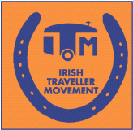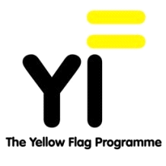
Yellow Flag Programme - Applications Sept 2013/June 2014
Some criteria and application information that we would like you to be aware of before you apply.
Background to the Yellow Flag
The Yellow Flag Programme is a practical 8 step school based programme, which provides a framework to develop a school environment where every child is valued and included and unfair racist bullying and discrimination is challenged. Please see www.yellowflag.ie for further information.

* Due to funding restrictions we are limited to the number of schools we can work with and we will apply the following criteria in the applications process.

Application criteria:

- Priority will be given to schools with Traveller students and who have previously applied to the programme.

- The staff team needs to be freed up for a two hour workshop on Interculturalism and Anti-Racism training.

- A voluntary contribution of €250 is requested from the school to go towards costs of support, resources, flags and travel expenses.

- ITM needs to secure a small grant of €3000 to take on each new school. We don’t expect the school to come up with this amount but instead we try to secure small grants from Local Authorities, Partnership Companies etc. Previously for example we have secured funding from Dublin City Council and have been able to work with schools in this area. Any support that a school can provide in relation to securing grants is welcome as are early applications to assist the funding process. The programme aims to work with 15 new schools this year.

The deadline for this round of applications is Extended to 17th of May 2013.

Application forms are available on our website www.yellowflag.ie/get_involved
Please call Paula Madden Yellow Flag Coordinator on 01 679 6577 / 087 241 0258 or email yellowflagprogramme@gmail.com for any further information and or to look at how we can work together to bring the Yellow Flag to your school.

