Procedures where there are allegations of suspicions of abuse by a Staff member
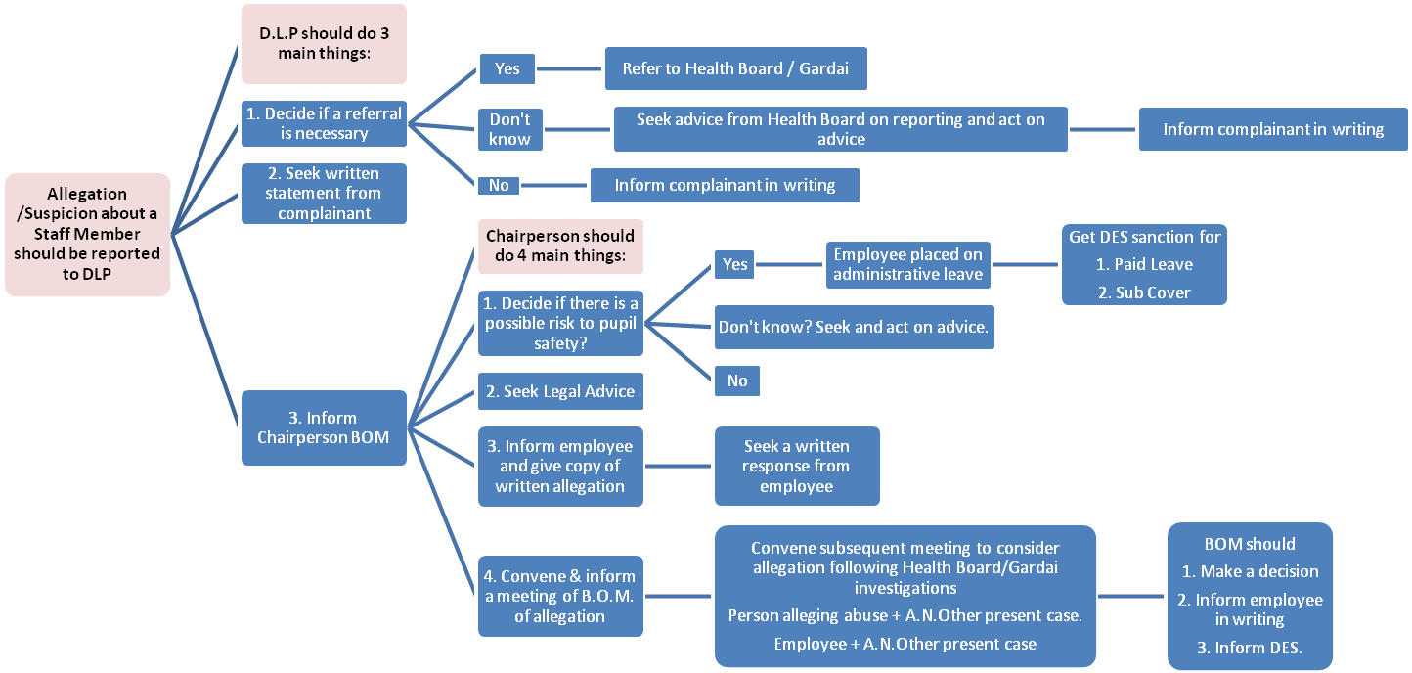
N.B. This document should be read in conjunction with the DES Child Protection Guidelines and Procedures.

