Procedures where there are allegations of suspicions of abuse by someone other than a staff member
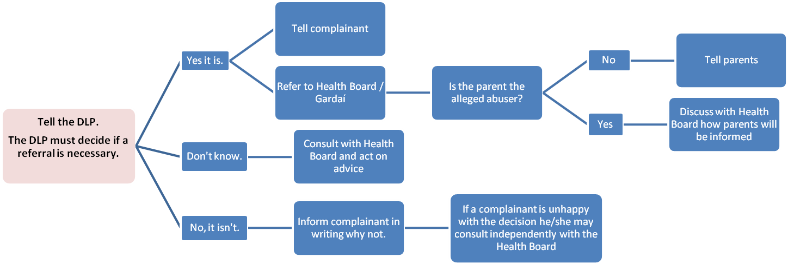
Some points:
• Keep a written record of complaint at all stages.
• B.O.M. should be appraised that a referral is being made to Health Board / Gardaí.
• If Principal is not DLP then Principal should be informed when there are suspicions or allegations of abuse.

